Risk Management Plan
HawkEye OSINT Analysis Project

Table of Contents
Table of Contents 1
1. Introduction 2
2. Risk Management Approach 2
3. Risk Identification 3
4. Risk Categories 4
4.1 Technical Risks 4
4.2 Schedule Risks 5
4.3 Resource Risks 5
4.4 Data Risks 5
4.5 Quality and Accuracy Risks 6
4.6 Team and Communication Risks 6
4.7 Ethical and Security Risks 6
5. Risk Assessment Method 7
6. Risk Mitigation Strategies 8
7. Risk Monitoring Plan 9
8. Risk Response Plan 10
9. Contingency Planning 11
10. Risk Documentation 12
11. Conclusion 12

1. Introduction
This Risk Management Plan outlines potential risks for the HawkEye OSINT Analysis project, possible countermeasures, and general responsibilities for managing those risks throughout the project lifecycle.
The HawkEye project is developing a Python-based, open-source desktop application that tests whether images are being used out of context. It is designed to analyse news posts on Reddit, perform reverse image searches, extract relevant information from online news articles, and use the Google Fact Check API to verify findings. The application also generates a perceptual hash of the image, uses a local large language model to compare findings, and displays results through a PySide6-based graphical user interface. Results can also be saved and viewed in PDF and JSON format.
Due to the nature of this project, several risks have been identified across the following areas:
- External APIs and data sources
- Hardware limitations
- Web scraping reliability
- AI-generated analysis accuracy
- Team coordination
- Ethical and accuracy considerations

This plan covers risk identification, risk assessment, assignment of responsibility, mitigation planning, risk monitoring, and response strategies. The overall goal is to prevent project delays while helping the team create a product that is stable, ethical, useful, and meets course objectives.
The HawkEye project is time-sensitive, with development intended to be completed within two weeks. The first week focuses on building the pipeline, connecting the required APIs, writing the web scraping code, and integrating the large language model. The second week focuses on building the GUI, writing tests, documenting the code, creating a demo video, and releasing the project on GitHub. It is therefore essential that potential risks are identified and managed early. A structured risk management process will help the team complete the project on time and maintain working code throughout development.

2. Risk Management Approach
The team will use a proactive approach to identify, prevent, and mitigate potential risks before they become larger problems. Risks will be continuously reviewed and assessed, and appropriate team members or sub-teams will be assigned responsibility where necessary. Each risk will be documented in a project risk log, while this written plan will guide the team's risk management decisions.
HawkEye project risks will be discussed in team standups, sub-team meetings, and weekly progress reviews. The project lead will coordinate the overall risk management process. Sub-team leads will be responsible for managing risks specific to their part of the system. The HawkEye team is organised into four sub-teams:
- Ingestion team
- Search team
- Intelligence team
- GUI and Release team

This structure allows project risks to be addressed by the team members most knowledgeable about each part of the system. The risk process will follow five main steps:
- Identify potential risks to the project's schedule, quality, functionality, or final delivery.
- Assess risks based on probability and impact.
- Rank risks so the most critical issues are addressed first.
- Develop mitigation strategies to prevent risks from occurring or reduce their effects if they occur.
- Continuously assess, monitor, and respond to emerging risks throughout the project lifecycle.

This approach ensures that risk management is incorporated into the project as an ongoing process rather than treated as an occasional exercise.

3. Risk Identification
Potential risks will be identified early in the process, starting from the planning phase. The team will evaluate the technical architecture, conduct tests, discuss concerns during meetings, and review recent development progress. HawkEye is a technical product made up of several modules, so potential issues can appear at any stage from design to testing. For example, a Reddit post may fail to load, the reverse image search API may reach its monthly quota, a website may block article scraping, or a local LLM may generate a verdict with very little evidence to support it.
Sources for risk identification include:
- Review of the project proposal and system architecture
- API documentation and usage limits
- Integration testing for Reddit, SerpAPI, TinEye, Google Fact Check, and article scraping
- LLM testing and prompt evaluation
- GUI testing and report export testing
- GitHub pull request reviews
- Team standups and blocker reports
- Final testing against labelled datasets and demo examples

During risk assessment, the team will pay special attention to risks that negatively affect the following core aspects of the project:
- Acquiring and processing data
- Understanding the context of an image
- Presenting evidence properly in the GUI
- Documenting project decisions
- Publishing a functional application to GitHub before the end of the project period

Risks affecting these core areas will be noted as high priority.

4. Risk Categories
Project risks are grouped into the following categories to make identification and management easier. The diagram below shows which stages of the HawkEye pipeline are directly affected by the two highest-impact technical risks identified during development.
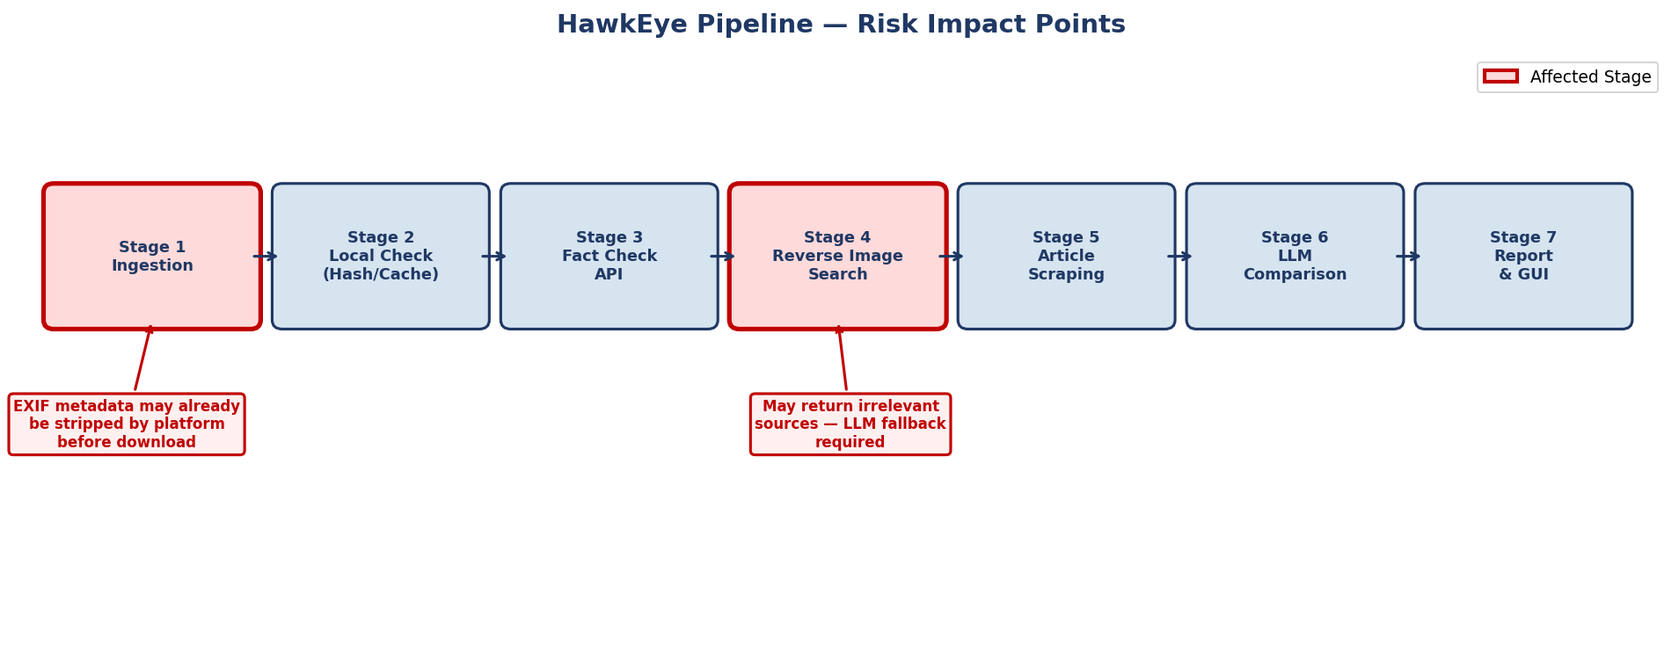
Figure 1: HawkEye Pipeline — Risk Impact Points (Stage 1: EXIF Metadata Loss, Stage 4: Reverse Image Search Reliability)

4.1 Technical Risks
Technical risks are issues related to software, external APIs, algorithms, system performance, and integration of software components. For HawkEye, these risks include:
- Failure of the Reddit API
- Limitations in reverse image search tools returning imprecise or irrelevant results
- Failure of article scraping on paywalled or JavaScript-heavy websites
- Reduced local LLM performance on lower-specification hardware
- Bugs in the GUI or report export functionality
- Database or cache corruption
- Loss of image EXIF metadata due to platform stripping, removing potentially useful forensic context such as geolocation and camera information
- Failure or limited availability of historical archive tools such as Wayback Machine and archive.today
- Incomplete or missing archived webpage captures, making it difficult to confirm whether an article’s title or content changed over time
- URL safety tools such as URLhaus and crt.sh returning incomplete, outdated, or unavailable results
- Slow response times, downtime, or rate limits from additional external services used for webpage history and URL safety checks

4.2 Schedule Risks
Schedule risks are issues that could cause the project to be completed late. Since the project has a short two-week development window, a delay in one component can affect other sub-teams. For example:
- Delayed reverse image search integration may affect the Intelligence team, as they depend on historical image context to test the LLM comparison step
- GUI delays may affect the final demo and GitHub release
- Late integration of sub-team components may prevent end-to-end testing

4.3 Resource Risks
Resource risks relate to limited tools, hardware, time, and API access. HawkEye may depend on tools and services that have request limits or hardware requirements. Specific resource risks include:
- API free-tier quotas being exhausted during repeated testing
- Local hardware being insufficient to run larger LLM models efficiently
- Limited development time reducing the scope of testing and documentation

4.4 Data Risks
Data risks involve data availability, quality, and reliability. These include:
- Some Reddit posts may not contain a usable image
- Reverse image searches may return few or unrelated results
- Scraped articles may lack usable text due to paywalls, heavy JavaScript rendering, or minimal content
- Image EXIF metadata may be stripped by the hosting platform before the image is downloaded, meaning geolocation coordinates, camera model, and original timestamp are unavailable for analysis
- Archived webpage versions may be missing, incomplete, blocked, or different from the live page, limiting the reliability of historical content comparison

4.5 Quality and Accuracy Risks
Quality and accuracy risks relate to the correctness and reliability of HawkEye's verdicts. Since the tool uses a local LLM to compare historical data with the Reddit claim, there is a risk of:
- Hallucination or overconfident classification of a post as Consistent, Out of Context, or Inconclusive
- The LLM citing evidence snippets that do not appear in the retrieved article text
- Incorrect verdicts on edge cases such as highly generic images or ambiguous captions
- URL safety checks may produce false positives by flagging a domain as suspicious even when the current article is legitimate
- URL safety checks may produce false negatives if a harmful or unreliable domain does not appear in URLhaus or crt.sh
- Technical safety indicators may be misunderstood as proof that an article is false, even though they only show possible domain-level risk

4.6 Team and Communication Risks
Team and communication risks include:
- Miscommunication or unclear roles across sub-teams
- Duplicated work due to insufficient coordination
- Missed deadlines causing cascade delays
- Merge conflicts between sub-teams working in the same GitHub repository

4.7 Ethical and Security Risks
Ethical and security risks include:
- Overstating confidence in uncertain results
- Incorrectly flagging legitimate content as misleading
- Misusing scraped data or violating terms of service of external APIs and websites
- Publishing a tool that could be misused to discredit valid content
- Overstating the meaning of URL safety results and incorrectly treating suspicious infrastructure as proof of misinformation
- Misleading users if archived webpage comparisons are presented as complete when only partial historical captures are available
- Creating reputational harm by labeling a domain or article as suspicious without clearly explaining the limits of URLhaus, crt.sh, Wayback Machine, or archive.today data

5. Risk Assessment Method
Each risk will be assessed using three factors: probability, impact, and priority. The risk matrix below plots all identified risks by their probability and impact ratings, with the two new risks (R9 and R10) highlighted.
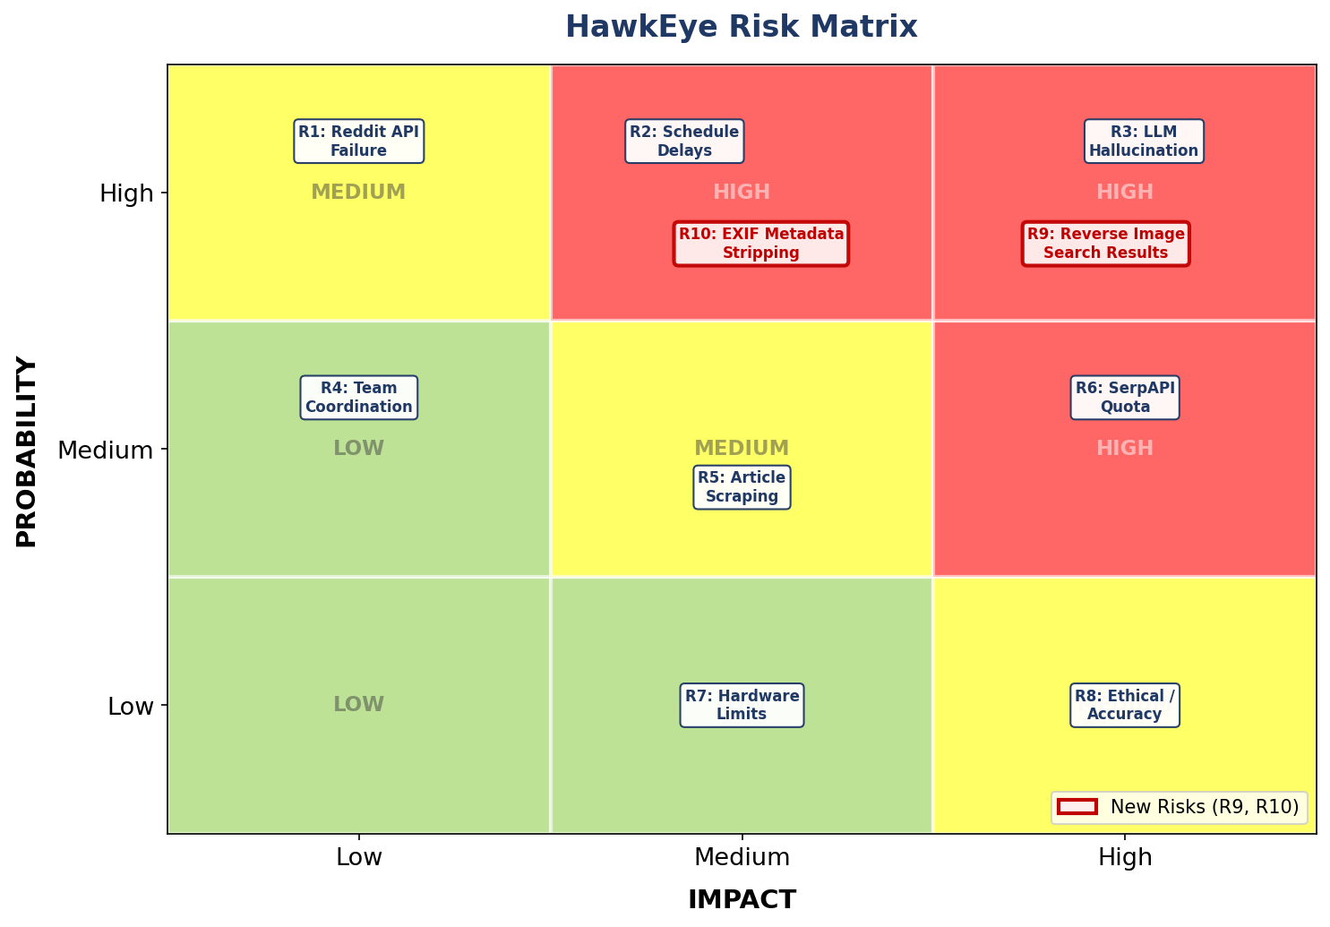
Figure 2: HawkEye Risk Matrix — All identified risks plotted by probability and impact (R9: Reverse Image Search Results, R10: EXIF Metadata Stripping)
- Probability measures how likely the risk is to occur. It will be rated as Low, Medium, or High.
- Impact measures how serious the effect would be if the risk occurred. It will also be rated as Low, Medium, or High.
- Priority combines probability and impact to decide which risks need the most attention. High-probability and high-impact risks will be addressed first.

For example, SerpAPI quota limits are a medium-to-high probability risk because free-tier API limits can be reached during repeated testing. The impact is high because reverse image search is one of the most important parts of HawkEye's pipeline. This risk is therefore treated as high priority.
LLM hallucination is another high-impact risk. Even if the application runs correctly, an unsupported or overconfident verdict could reduce the credibility of the entire project. The team must build safeguards around the LLM output to address this.
Not all risks will be treated equally. Minor formatting issues in a PDF export are lower priority than a failed image search pipeline. However, even lower-priority risks will be documented so they can be addressed if time allows.

6. Risk Mitigation Strategies
Risk mitigation focuses on reducing the chance that a risk will happen or reducing the damage if it does. The HawkEye project will use the following strategies:
API Quota Risks
The team will use caching through a local SQLite database. Since HawkEye uses image fingerprints and perceptual hashing, the same image will not need to be analysed repeatedly. If a result already exists in the cache, the tool will return the stored result instead of making another API call, reducing unnecessary usage of SerpAPI, TinEye, and fact-check API credits.
Reverse Image Search Reliability Risks
SerpAPI's Google Lens endpoint will serve as the primary reverse image search tool, with TinEye as a fallback. If SerpAPI is unavailable or out of quota, the application will attempt to retrieve image matches through TinEye. If neither tool returns sufficiently relevant results for the use case, the pipeline will proceed using article text retrieved through other means, and the report will document the limitation clearly.
Article Scraping Risks
The team will use multiple scraping methods in sequence. If one tool fails to extract clean article text, another method will be attempted. If a website is paywalled, blocked, or inaccessible, the source will be marked as inaccessible rather than silently removed, making the system more transparent and helping users understand why some evidence may be missing.
LLM Accuracy Risks
The model will be required to return structured JSON output containing a verdict, confidence score, reasoning, and specific evidence snippets. A confident verdict will not be accepted unless the cited evidence appears in the retrieved article text. If the model cannot support its conclusion with evidence, the verdict will be downgraded to Inconclusive. This reduces the risk of hallucinated or unsupported claims.
Hardware Performance Risks
The default LLM will be a smaller local model capable of running on lower-specification hardware, while larger models remain optional for more powerful machines. The number of articles sent to the model will be limited to the most relevant sources to reduce processing time. The README will document minimum hardware requirements clearly.
Image Metadata Loss Risks
EXIF metadata extraction will be performed immediately upon image download, before any further processing. If metadata is present, it will be logged and passed downstream as supporting evidence. If metadata is absent due to platform stripping, the pipeline will continue normally and the report will note which fields were unavailable. Confidence scoring will account for cases where the verdict rests solely on scraped article text with no corroborating metadata.
Schedule Risks
The team will prioritise the core pipeline before optional features. The most important goal is to produce a working application that can ingest an image and claim, search for prior appearances, compare contexts, and display a verdict with evidence. Additional features should only be added after the core tool is stable.
Team Coordination Risks
GitHub pull requests will be required before merging into the main branch. Each pull request must be reviewed by at least one person outside the author's sub-team. This reduces merge conflicts, improves code quality, and ensures team members remain aware of changes in other parts of the project.
Historical Webpage Verification Risks
The team will use Wayback Machine and archive.today to check if a webpage existed in the past and whether anything changed over time. If old versions are found, they will be compared to the current page. If nothing is found, the report will say so. A missing archive record does not mean the article is fake or suspicious.
URL Safety Risks
The team will use URLhaus and crt.sh to check if there are any technical concerns with the website hosting an article. These checks look at the domain and server, not the article itself. A flagged domain does not mean the article is wrong. A clean result does not mean the article is trustworthy. The report will make that clear.
If either tool fails to return results or finds nothing, that will be noted and the review will continue using other available information.

7. Risk Monitoring Plan
Risks will be continuously monitored throughout the project lifecycle. The project lead will review the risk log and update the likelihood, impact, and status of identified risks. Sub-team leads will monitor and assess risks within their area of responsibility.
The team will monitor risks through:
- Regular standup meetings
- Discord blocker updates
- Trello task progress
- GitHub issues and pull requests
- API usage tracking
- Testing results
- GUI and export testing
- LLM output reviews
- Historical archive result availability from Wayback Machine and archive.today
- URL safety result availability from URLhaus and crt.sh
- False positives or false negatives in URL safety outputs
- Cases where archived webpage captures are incomplete or unavailable

High-priority risks will be discussed during standups until they are resolved. If the Search team discovers that article scraping fails on a large proportion of sites, the team may add a fallback method, such as using the article title and snippet when full text cannot be extracted.
The team will pay close attention to API usage because repeated testing can quickly consume available credits. Caching and pre-collected test content will be used where possible to reduce API usage.
Testing will also serve as a monitoring tool. If the tool produces too many false positives or false negatives, the Intelligence team can adjust the prompt, evidence filtering, or verdict logic. The GUI and Release team will prioritise stability over visual appearance for the initial release.

8. Risk Response Plan
If a risk occurs, the team will address it based on its severity and impact on the project. The four main response strategies are:
- Avoidance — modifying the scope or plan to avoid the risk. For example, instead of supporting multiple social media platforms in v1, the team may focus only on Reddit and direct image-and-claim input.
- Mitigation — reducing the impact of a risk. For example, if the local LLM is too slow, the team can send fewer source articles, use a smaller model, or simplify the prompt.
- Transfer — assigning the risk to the right person or using a backup plan. For example, if SerpAPI fails, the team can rely on TinEye or cached results.
- Acceptance — choosing not to spend significant time on a lower-priority risk unless it becomes more critical. For example, minor UI cosmetic issues may be accepted temporarily while the team focuses on core functionality.

Specific response examples include:
- If SerpAPI runs out of quota, use TinEye and cached results.
- If neither reverse image search tool returns relevant results for the demo dataset, use the saved demo dataset for model evaluation and document the limitation.
- If Reddit ingestion fails, allow direct image and claim input so the pipeline can still run.
- If the LLM provides unsupported reasoning, change the verdict to Inconclusive.
- If article scraping fails, mark the source as inaccessible and continue with other available sources.
- If EXIF metadata is absent from the downloaded image, flag the missing fields in the evidence view and continue with article-based analysis. Absence of metadata is treated as a known platform limitation, not as evidence the image is fake.
- If the GUI is not finished in time, ensure the command-line version works and use that for the demo.
- If live API calls or internet access interfere with the final demo, use cached results, screenshots, or a recorded demo.
- If integration becomes unstable, freeze new features and focus on stabilising the core pipeline.
- If Wayback Machine or archive.today cannot provide a usable archived version, the system will continue the analysis and clearly state that historical webpage verification was limited or unavailable.
- If archived content is incomplete, the comparison will be marked as partial, and the system will avoid making a strong conclusion based only on that evidence.
- If URLhaus or crt.sh fail or return unclear results, URL safety verification will be marked as unavailable, and the analysis will continue using other evidence.
- If a domain is flagged as suspicious, the result will be shown as a technical warning, not as proof that the article is false. If no suspicious records are found, the report will only state that no suspicious indicators were found from those tools.

9. Contingency Planning
Even with mitigation, some risks may be outside the team's control. The team will therefore prepare backup plans for major issues.
To demonstrate the application if live APIs are unavailable, the team will cache a small amount of test data. This may include known test images from labelled datasets such as Fauxtography or MediaEval, along with hand-labelled Reddit examples.
The team will also cache API results during development so they can be reused during testing or presentation if necessary.
A working command-line tool will be maintained throughout development in case the GUI is not fully ready for the deadline. The GUI is the intended final deliverable, but a stable backend pipeline takes priority for ensuring the application works end-to-end.

10. Risk Documentation
The risk log will list all risks that need to be tracked for this project and will be updated as the project progresses. The written Risk Management Plan explains the process, while the risk log serves as the living document for individual risks.
Each risk entry in the risk log will include:
- Risk ID
- Risk description
- Risk category
- Probability rating
- Impact rating
- Priority level
- Risk owner
- Mitigation strategy
- Monitoring method
- Response plan
- Current status
- Notes or updates

The risk log will be updated when a new risk is identified, when a risk rating changes, when a mitigation strategy is completed, or when a risk is closed.

11. Conclusion
The HawkEye OSINT Analysis project faces several risks due to its heavy reliance on external APIs, web scraping, and local AI models, all within a constrained two-week development window. Most of these risks can be mitigated and managed through early planning, assigned roles and responsibilities, regular tracking and monitoring, use of backup tools and techniques, data caching, thorough testing, and open communication.
Effective risk management will result in a stable, professional, and successful application that fulfils the aims of the project. It is important that no single issue — whether reaching an API quota limit, a failure of web scraping, an error in the LLM, or a problem rendering the GUI — prevents the project from being completed. This requires identifying possible fallbacks, documenting known risks, and prioritising them throughout development. Once core functionality has been met, additional features can be considered with a view to minimising risk to the final product.

